February 19, 2022

*Via E-mail:* <<ADJUSTER_EMAIL>>

<<INSURANCECOMPANY_SUITNAME>>

c/o Claims Department

***RE:* Letter of Representation and Request for Payment**

**Insured:** <<INJUREDPARTY_NAME>>

**Property Address:** <<INJUREDPARTY_FULL_ADDRESS>>

**Claim No.:** <<INS_CLAIM_NUMBER>>

**Date of Loss:** <<ACCIDENT_DATE>>

**Amount Claimed:** $<<BALANCE_AMOUNT>>

**Our File No:** <<CASE_ID>>

To whom it may concern:

Please be advised that this firm represents <<PROVIDER_SUITNAME>> in the above captioned matter. Please direct any and all future communications to the undersigned.

Please contact me at your earliest convenience to discuss resolution of this claim without litigation. Please mail all checks to our office payable to our Trust Account, or to the Provider and our firm.

Sincerely,

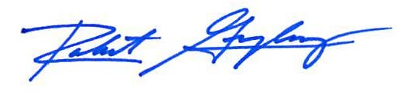

Robert F. Gonzalez, Esq.